Statistics Bible Summary

# Modeling for exploration

* Most crucially, looking at the raw data values.
* Computing summary statistics, such as means, medians, and interquartile ranges
* Creating data visualizations.

At the end, it should have:

* A sense of the distributions of the individual variables in your data
* Whether there are outliers and/or missing value
* Whether any potential relationships exist between variables

**Statistical inference** is the act of making a guess about a population using a sample.

# Correlation calculation

The correlation coefficient is invariant to linear transformations.

|  |  |
| --- | --- |
|  |  |

# Linear Regression

library(moderndive)

Minimum number of observations per coefficient

## Model Creation

### 1 numerical explanatory variable

|  |  |
| --- | --- |
|  |  |

We can use I() to elevate a variable.

### 1 categorical explanatory variable

We can also eliminate the Intercept by writing “+0” after the variable.

|  |  |
| --- | --- |
|  |  |

|  |  |
| --- | --- |
|  |  |

### 1 numerical and 1 categorical

**+** allows us to get one slope for both categories.

|  |  |
| --- | --- |
|  |  |

**\*** allows us to get all model interactions. In this case we will have an interception and one slope for each categorical variable.

|  |  |
| --- | --- |
|  |  |

We can get the same result by writing the interaction by hand.

We can limit interaction level using the next syntax

### 2 or more Numerical variables

*Taking into account all the other explanatory variables in our model*, for every increase of one unit in income (i.e., $1000), there is an associated decrease of on average $7.663 in debt.

|  |  |
| --- | --- |
|  |  |
|  | |

### 2 Numerical and 1 categorical

## Model selection

We should try to keep the model as simple as possible. Here is an example where adding the interaction doesn’t affect the result too much.

|  |  |  |
| --- | --- | --- |
|  | |  |
|  |  | |

## Math under regression hypothesis test

|  |  |
| --- | --- |
|  | |
|  |  |

## Checking regression quality with ggfortify

## Making predictions with the model

Una variable predictiva

Varias variables

Una variable transformada

Graficar las predicciones del modelo

## Simpson’s Paradox

Simpson’s Paradox occurs when trends that exist for the data in aggregate either disappear or reverse when the data are broken down into groups.

**To avoid problems**

* Articulate a question before you start modeling.
* Allow the question to select the model
* Try to plot the dataset y different ways
* Add more variables to the model and create charts

Modeling the whole dataset suggests that playing more video games is related to a higher test score. If we reveal that each group represents the age of the child taking the test, it changes the interpretation. Now older children score more highly in the test, and playing lots of video games is related to a lower score.

## Extracting model components

### Base R

|  |  |  |
| --- | --- | --- |
| *Extraer los coeficientes* | *Extraer las predicciones con la data de entrenamiento* | *Extraer los residuales del modelo* |
|  |  |  |
| *Resumen del modelo con la data de entrenamiento* | | |
|  | | |

### Broom package

RSE == sigma

Leverage == .hat

Influence == .cooksd

# Inference process

## Possible scenarios

## Importance of sampling

|  |  |
| --- | --- |
| Table  Description automatically generated  If the sampling of a sample of size *n* is done at ***random***, then the ***sample is unbiased***and ***representative of the population*** of size N, thus any result based on the sample can **generalize to the population**, thus the ***point estimate is a “good guess”*** of the unknown population parameter, |  |

## Confidence interval

### Confidence level

To define the confident interval, we need to specify a ***confidence level***. Higher confidence levels tend to produce wider confidence intervals.

**Precise interpretation:** *If we repeated our sampling procedure many times, we expect about* ***95% of the resulting confidence intervals*** *to capture the value of the population parameter.*

|  |  |
| --- | --- |
| 95% Percentile | 80% SE |

### Sample size

|  |  |
| --- | --- |
|  |  |

## Bootstrap

If we take a sample and resample it with replacement, we can create ***Bootstrap Distribution of the Sample Mean*** which approximates the ***Sampling Distribution of the Sample Mean***. That will open the possibility to create ***confidence intervals*** of a sample, but it doesn’t affect the mean.

1. The ***bootstrap distribution*** will likely not have the same center as the ***sampling distribution***.
2. ***Bootstrapping*** will give you a good estimate of the standard error.

### Manual implementation

|  |  |
| --- | --- |
|  |  |

For example, we could be 95% “confident” that a 95% confidence interval captures the value of the population parameter.

* Percentile method

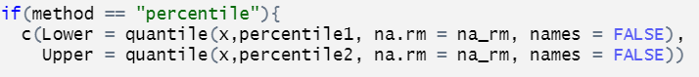

* Standard error method

we can only this method when the bootstrap distribution is roughly normally shaped.

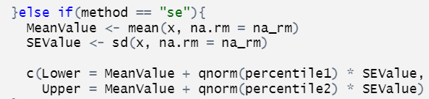

|  |  |
| --- | --- |
|  |  |

### Infer implementation

|  |  |
| --- | --- |
|  |  |
|  | |

|  |  |
| --- | --- |
|  |  |
|  |  |

## Permutation testing

The term “permutation” is the mathematical term for “shuffling”: taking a series of values and reordering them randomly, as you did with the playing cards. While the bootstrap method involves resampling with replacement, permutation methods involve resampling without replacement.

* The ***null distribution*** is the sampling distribution of the test statistic assuming the null hypothesis H0 is true.
* The ***p-value*** is the probability of obtaining a *test statistic* just as extreme or more extreme than the observed test statistic assuming the null hypothesis H0 is true. For example, The p-value represents for the likelihood that the true mean for the promotion rates for males and females in the population is the same.

If the p-value falls below α, we would “reject the null hypothesis H0”. Alternatively, if the p-value does not fall below α, we would “fail to reject H0”. At the α = 0.05 significance level.

**Using non-statistical language:** we found enough evidence in this data to suggest that there was gender discrimination at play.

### Infer implementation

* Calculating the Null Distribution

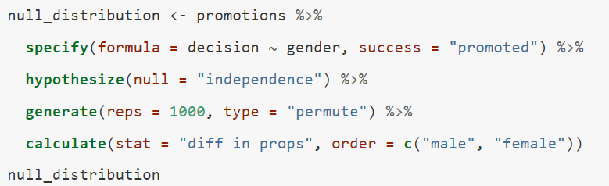

* Calculating the observed test statistic

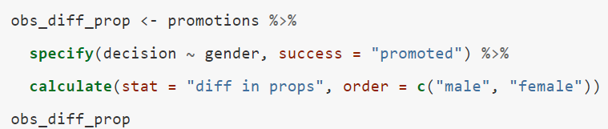

* Calculating p-value

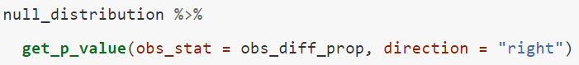

* Visualize results

